**SCOPE DOCUMENT**

**Project:** Develop e-commerce selling Game software

**Development Company:** The games

**Client:** FPT

**1. Descriptions of project :**

The games Company (our client) is in need of a comprehensive software solution for the creation and management of an online gaming platform, similar to renowned gaming marketplaces like Epic Games. Our goal is to deliver an exceptional gaming platform that allows gamers to access, purchase, and enjoy a wide range of digital games and related content.

We provide the best solution with the most friendly-user experience for the web application with widely accessible games around the world and also provide many tools for managing marketplaces and games. We also provide documents and files for The Games Company.

A service agreement was established between Vina Milk and The games Company (as the service provider) the Application will be deliver at the day of January 18th 2024

**a. Overall objectives :**

- O1: Understand the Process of web-application for selling games that users require to manage stores, account permission, Cart, Payment.

- O2: Develop the web-application and deploy in cloud

- O3 : Copyrights (Protect the game from being Crack/Private)

- O4: Testing and compete the web-application and Deliver to customer

- O5: Training Administration for the System and complete User Document.

**b. Justifications :**

**Expertise in e-commerce Development:** Our team comprises experienced game developers and software engineers with a proven track record in the gaming industry. We have successfully delivered similar projects, demonstrating our ability to create high-quality gaming platforms.

**Cutting-Edge Technology:** We leverage the latest technologies and industry best practices to develop state-of-the-art Selling games platforms. This ensures that our clients receive innovative and competitive solutions.

**Customization and Scalability:** Our solutions are highly customizable to meet the unique needs of The Games Company. We understand that flexibility is essential in the gaming industry, and our platform will be designed with scalability in mind to accommodate future growth.

**Timely Delivery:** We are committed to delivering the gaming platform by January 18th, 2024, as specified in the service agreement. Our project management and development processes are designed to ensure on-time delivery.

**Cost-Effective Solutions:** We offer cost-effective solutions that align with The Games Company's budget while maintaining the highest quality standards we provide the best solution and the most balance for budged, time and quality.

**- Customer’s benefits:**

**Enhanced User Experience**: Gamers will enjoy an exceptional user experience, with user-friendly interfaces, robust search and navigation features, and secure payment options.

**Vast Game Library**: The platform will feature a vast library of digital games and related content, providing gamers with a wide range of options to choose from.

**Scalability**: The platform is designed to grow with The Games Company's needs. As the user base expands and new games are added, the platform can easily accommodate increased traffic and content.

**Efficient Store Management**: The Games Company will benefit from efficient store management tools, including account permission settings, shopping cart management, and analytics for better decision-making.

**Cloud Deployment**: By deploying the platform in the cloud, The Games Company can enjoy scalability, accessibility, and reduced infrastructure costs.

**Training and Documentation**: We will provide comprehensive training for system administrators and deliver user documentation, ensuring a smooth transition to the new platform.

**Competitive budged**: The platform will give The Games Company a competitive edge in the gaming industry by offering a feature-rich and user-friendly gaming experience to its customers.

**2. Deliverables :**

| No. | Deliverable | Detail Characteristics | Date of Delivering |
| --- | --- | --- | --- |
| 1 | User requirement | Stakeholders | 21 / 09 / 2023 |
| 2 | General Survey | Stakeholders | 29 / 09 / 2023 |
| 3 | Financial Planning | Stakeholders | 30 / 09 / 2023 |
| 4 | Design GUI | Stakeholders | 28 / 10 / 2023 |
| 5 | User Document | Staffs, Stakeholders | 02 / 12 / 2023 |
| 6 | Project Results | Stakeholders | 06 / 12 / 2023 |
| 7 | Train client to fully use the software | All department’s staffs | 30 / 11 / 2023 |

**3. Further statements :**

**a. Acceptance criteria :**

The system will have a secure login system with two layers of account authentication to increase user safety because this system involves a lot of transactions and buying and selling with money.

Secondly, because the system will reach a large number of young people, the user interface must meet the basic criteria (tight layout, images that match trends, display relevant information and are useful to users) for an interface designed according to modern trends.

The application is developed with 3 main types of users: user, administrator and game supply company. Depending on the user, the system will provide management capabilities according to their role. For example, the normal user will be able to manage the games in the cart and show the games that have been purchased. This is an extremely important criterion for a game distribution website project.

Build a responsive web application. Because the system needs flexibility in communicating with customers and this is also a feature that helps the application reach customers anytime, anywhere.

**b. Exclusions :**

The app will not provide AI to assist users, as most of the features are presented in a very simple way and they will be combined with a user-friendly interface. This will help reduce costs and time during project implementation and development.

The system does not support the provision of game titles that do not originate from game providers that have signed a contract with the game distribution company.

Does not support the purchase and sale of in-game items (including money) on the game distribution system.

Our application cannot guarantee that customers will provide their exact age.

**c. Constraints :**

**Budget:** The project budget is limited to $76000.

**Timeline:** The project must be completed within 4 months.

**Team Composition:** The project team will consist of at least one PM, 2 developers, 1 tester, 1 business contactor.

**Technology constraints**: Does not support systems running on special platforms or on operating systems that are not popular today.

**Identify constraints**: Each user can only register a unique account with a unique email.

**Constraints of selling :** We are not involved in any other payment or purchase of a game such as selling accounts, key games, or other methods.

**Constraints of Rule** : we are not responsible for any kind of crime in the game which may build it ways.

**Constraints of Law :** if there is any commit of crime related to our web-application we will provide and support the government squad to solve.

**4. Work Breakdown Structure and Critical Path Method :**

**a. WBS ( Work Breakdown Structure ) :**

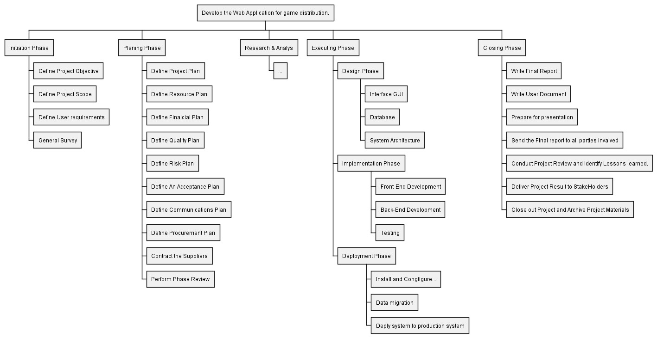

**b. CPM ( Critical Path Method ) :**

| Activity | Immediate Predecessor | Duration |
| --- | --- | --- |
| A. Define project objective | _ | 2 |
| B. Define project scope | _ | 4 . |
| C. Define user requirement | _ | 3 |
| D. General survey | A, B, C | 7 . |
| E. Define project planning | D | 3 . |
| F. Resource planning | E | 2 . |
| G. Financial planning | E | 2 . |
| H. Risk planning | E | 2 . |
| I. Acceptance planning | F, G, H | 2 |
| J. Research and Analysis | I | 15 . |
| K. Design GUI | J | 6 . |
| L. Design DB | J | 5 . |
| M. Design system architecture | L | 6 . |
| N. Front-end development | K | 10 |
| O. Back-end development | M | 15 . |
| P. Testing | N, O | 7 . |
| Q. Install and Configure web application | P | 3 . |
| R. Data migration | P | 1 |
| S. Deploy system to production system | R | 1 . |
| T. Write final report | S | 4 . |
| U. Write user document | T | 3 . |
| V. Prepare for presentations | U | 2 |
| W. Conduct project review and identify lesion learned | V | 1 |
| X. Deliver project result for stakeholders | W | 1 . |
| Y. Close out project and archive project materials | X | 1 |

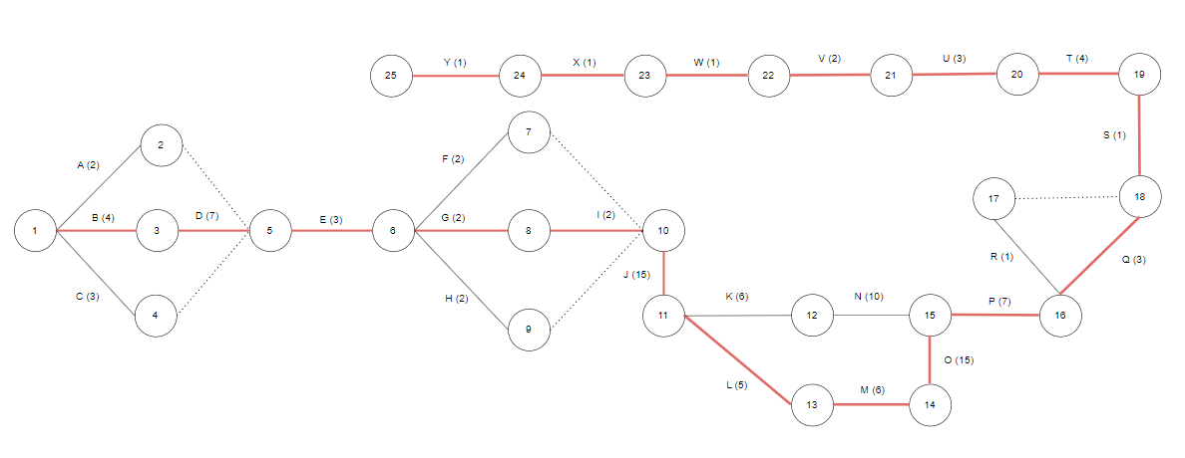

! Thank you for reading !